* Conference group
* Look at
* Frequency heatmap – read x-axis -> y-axis (columns and then rows)
* 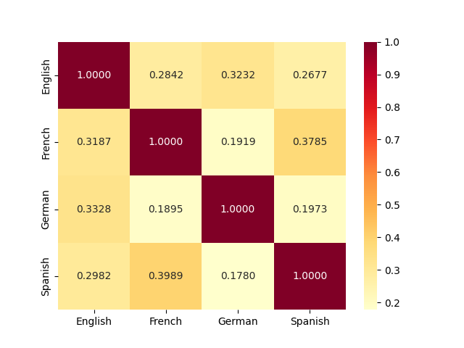
  + 0.0 - .23 difference range
  + 1.0 means nothing, every language is itself
  + Nothing is more dissimilar than 0.16 (no values less)
  + Nothing is less dissimilar than 0.40 (no values higher, more similar)
* I do not know significance of number difference
* Phonological differences
  + P and f are similar phonetically
  + Father -> vater -> padre
    - Place of articulation is similar
  + Cluster sounds by letters and give credits
    - P vs F gives 0.5 points
    - Variationa and change model
  + Total matches are full scores
  + Partial matches in same place
  + +/- voicing?
* **Re-run with 2000 words**
  + Scores change? Do we need to look further?
* **Craft description ~600 words** 
  + Partial match – partial score
  + Descriptions and examples (with descriptions)
  + If going EN->ES get higher score
    - Mean (average) in distance
    - EN -> ES learning is a little easier
    - Spanish is about 10% closer when EN->ES vs ES->EN
      * Careful! do not say if meanigful difference!
* What we do is similar to dialectometry
  + Use vowel similarity find dialectisoglosses
  + Draw line on maps b/t dialect regions
* **AJ – heading finding descriptions etc. slides for conference**
* **Communication, Conflict, and peace confer 9am about for our panel**
  + **Each panel has own registration**
  + **2 invitations – 1) for entire time; 2) for just our panel**
  + **Register for our group, be at our panel pls!**